IPDP Directions through Employee Kiosk

- Log into the employee kiosk through the tech page:
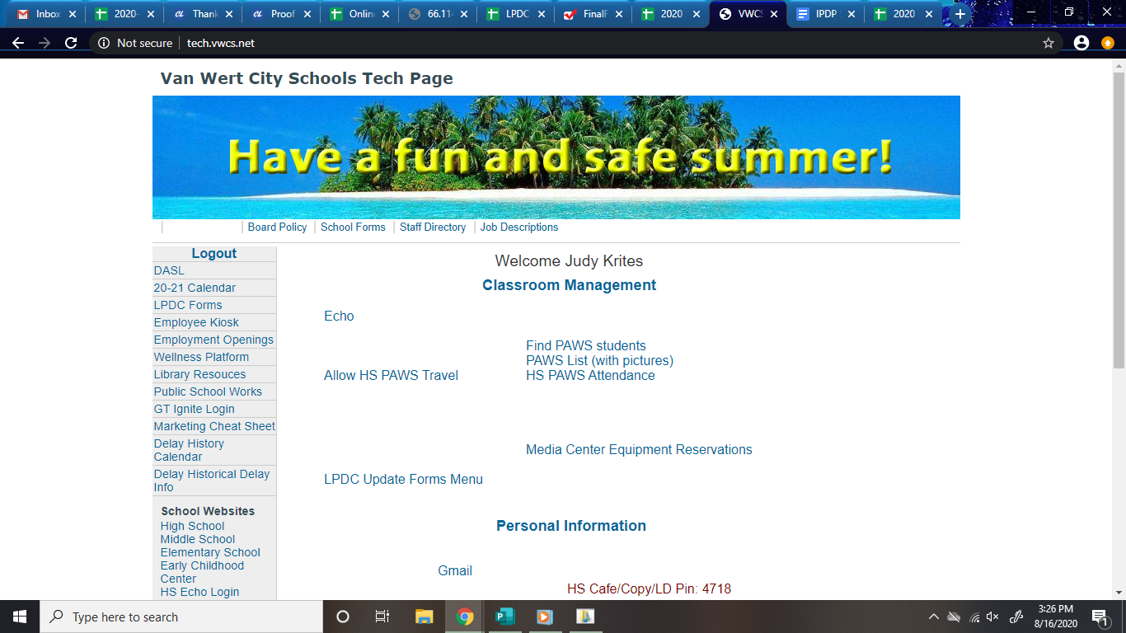

- Log-in as you would to request a sub or use the kiosk. This is your log-in and does NOT go through the LPDC.

- Choose the APPS drop down in the upper right task bar. Click on IPDP. 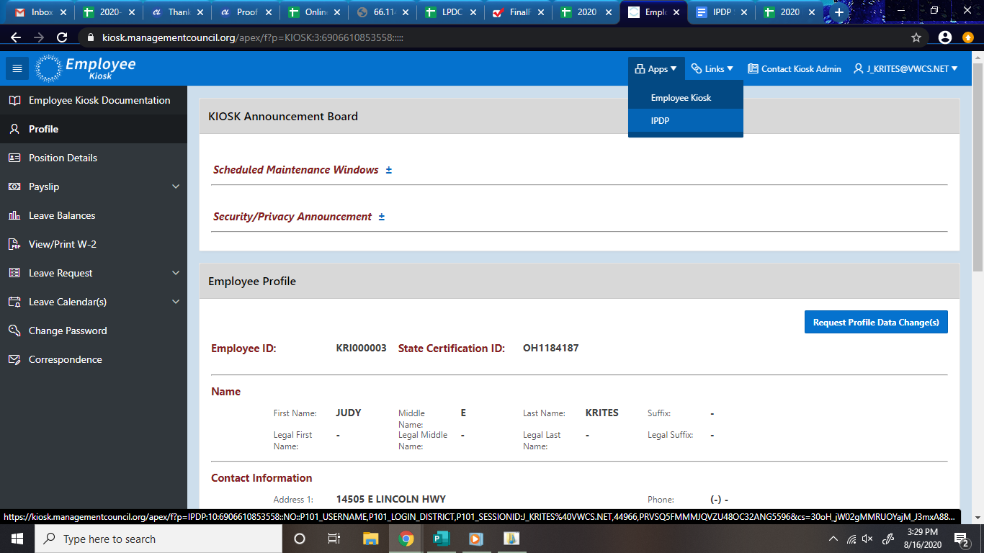

- The page you now see should have IPDP at the upper left and should show your license credentials. To create your IPDP choose create plan on the left side drop down listing.

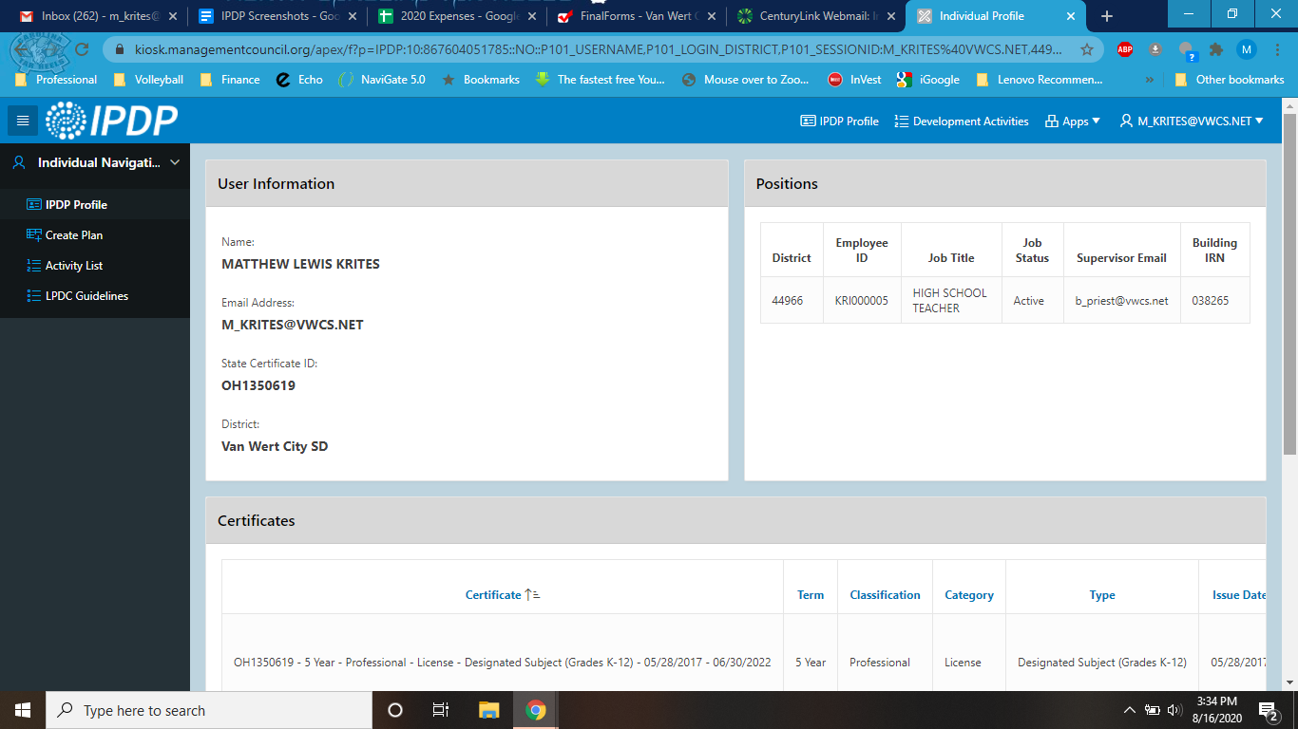

- Choose the select button for VWCS IPDP template.
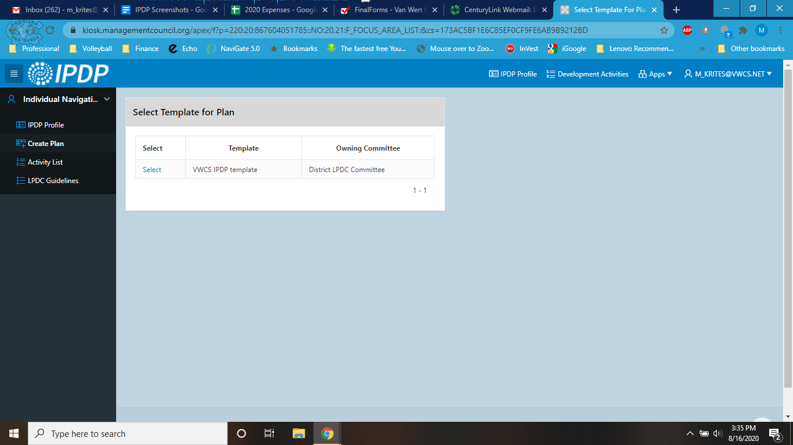

- Complete the Name of Plan with your name and “IPDP”. Leave the default “none” in supervisor. From the “version” drop down choose either “renewal of 5 year license” if you have had a 5-year license and have written and had approved an IPDP in the past. If you are transitioning from a Provisional or Alternative license to a 5-year license, choose transitioning to 5-year license.
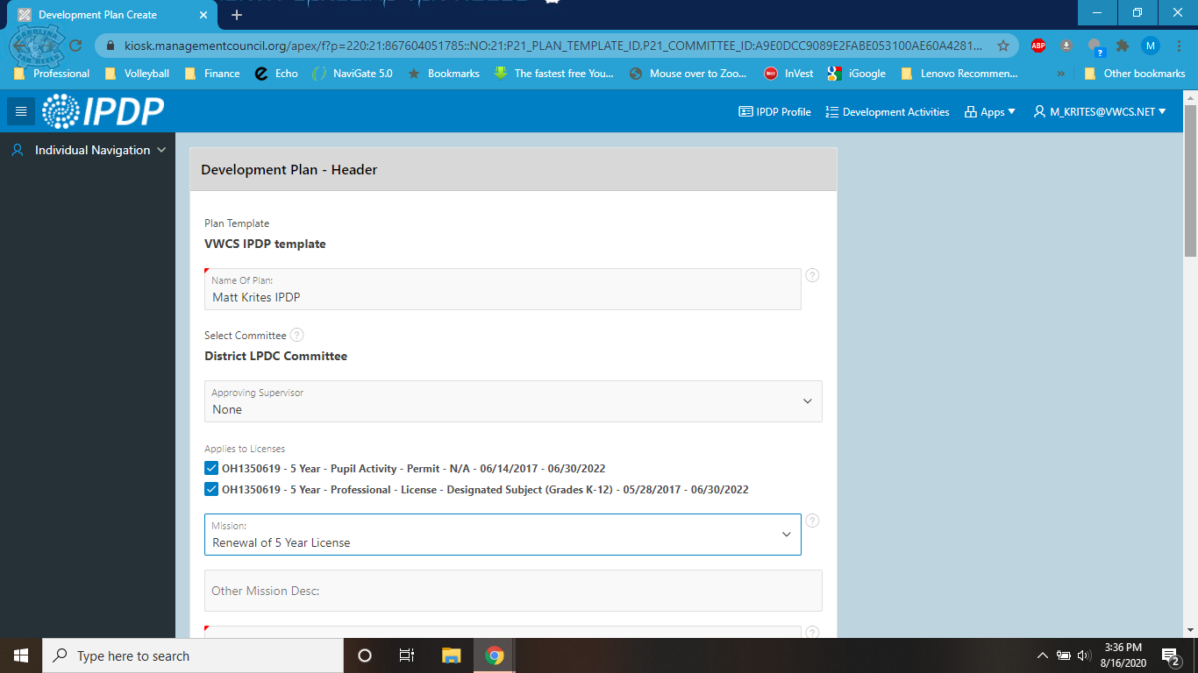

- Under the Other Mission Desc box, list your subject/position and building. (The box below has had the description changed.)
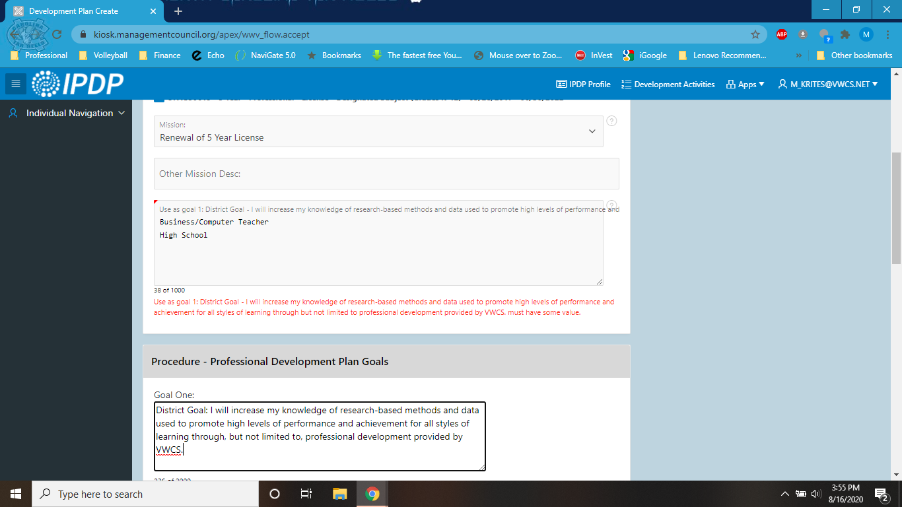

- Type in the District Goal into the Goal One box:
District Goal - I will increase my knowledge of research-based methods and data used to promote high levels of performance and achievement for all styles of learning through but not limited to professional development provided by VWCS.

- Write two or three other appropriate Professional Development goals for yourself. Remember these goals are what you intend to LEARN to be a better educator, not what you intend to do the in the classroom. Within the goal, include a general description of how you intend to complete the learning (college courses, webinars, seminars, etc.). You should have goals beyond school provided PD (NME, Literacy Collaborative, etc) as these are included in the district goal. Use the concept of a SMART goal which includes a time frame (within my 5-year license cycle) and a certain amount of specificity. Use the district goal as a general example.

- When you have completed your IPDP, submit your plan using the Submit Plan for Approval option. If you need to work on the IPDP more at a later time, choose the first option Create and Save Plan to Work on Later.
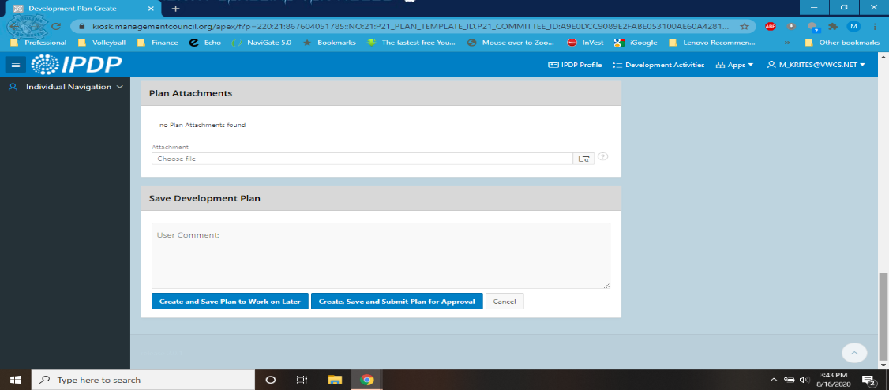

- The LPDC will review your IPDP soon after it is submitted. Please be patient. You will receive an email notification.

